Reflective essay
Journeyman 2024
Alfie Fish
During the journey man module, I was chosen to work as a gameplay and mechanics developer and so was tasked with creating blueprints for enemy ai, environmental mechanics and gameplay related puzzles. I feel that the journeyman module has provided me with many different opportunities to improve my scripting skills through working closely with the games programming students as well as other disciplines and has widened my understanding of the different roles within a game's studio.

Environmental mechanics

Island rotation
During the project i created an environmental mechanic to rotate different pieces of the level in order to complete puzzles and reach different areas whilst playing, as this mechanic was set to be used in multiple places I decided to create a rotation controller that when placed in the level would rotate any actor which was connected to it through an editable number of rotations. 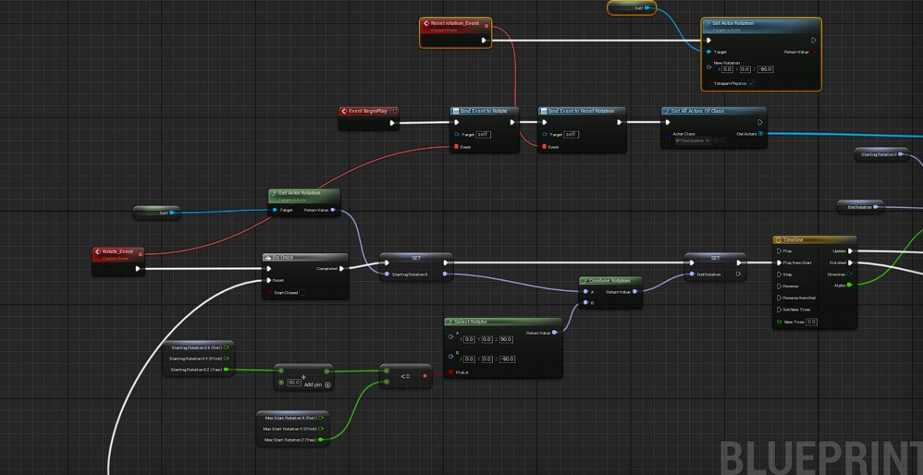 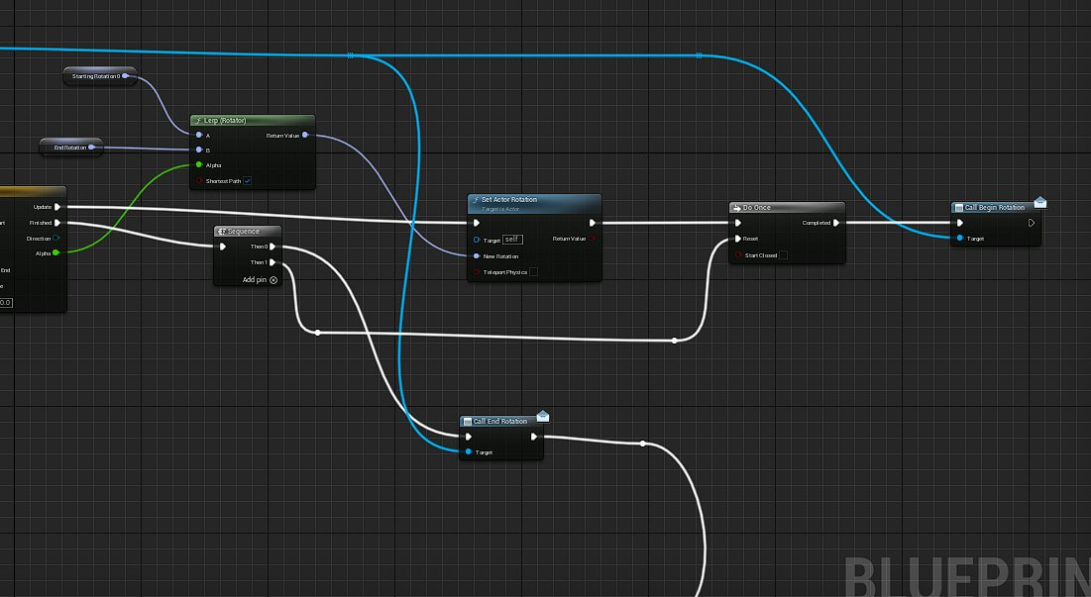
This simple approach allowed for the mechanic to be used in several places throughout both of our levels and meant that the blueprint could be connected to several different types of triggers if needed without hindering or effecting functionality in any way. I also chose to use timelines to control the rotation of the islands to give the rotation a more natural look of over shooting and then bouncing back to their desired end rotation. This concept could have been further improved by adding feedback to the player such as controller vibration or camera shake.

Laser puzzle
Along with the rotation mechanic I also created a functioning laser puzzle meant to have three lasers that would be activated by the player spread throughout the map which would then in turn when all were activated would meet in the center of the map at the temple to activate the final laser which could then be rotated to create the portal used to progress to the second mushroom themed island. This puzzle proved difficult to create and had recurring issues as the project progressed, however functioned well in the final parts of the project. I used my own blueprinting knowledge as well as tutorials from Pastanoob to create the necessary blueprints for the laser itself, a spawner, a central target for the temple and a final target to activate the portal. The laser at its core functions from a box trace by channel to determine the length it can travel before registering a hit on another object and then spawning a cylinder of that length with the glowing material assigned. The target however was more difficult to create and I decided to use an array of overlapping objects within the cental target to create the functionality as I had imagined it, the check is completed when the actor is hit by a laser to see how many are in contact with the target and if above a set number the final laser to the portal is activated. Using an array in such a way allowed for the puzzle to be scalable to more or less beams if necessary or the team had decided to reduce scope once again.
This system was fairly successful once finished however was a large undertaking and i had support from my lead programmer to optimize and bug fix throughout its development process.

Enemy AI
After completing my environmental mechanics, I was then moved onto helping to create and animate the enemies that would be placed around our level. We decided on different enemy types; one would be a standard patrolling enemy which would search for and the attack the player as they move through the level and the other a stationary plant which would function like a fixed turret from range with a melee attack when the player got within its range.
Ai has been a lacking area in my scripting skills which I explained to my leads when I was assigned this task however, I was eager and ready to take on the challenge and improve my skills in the area. I was supported through the development of our enemies by our producer Kyle who helped with a basic behavior tree. I was also in contact with one of the animators who helped me to find documentation regarding blend spaces, animation blueprints and the process for implementing animation montages. I now feel that I am more confident in my skills and the implementation of AI systems within games, and it is another way that the journeyman module has helped me to progress in both technical and soft skills.

Monkey enemy
The ai functionality for this enemy was primarily worked on by our producer kyle however i was tasked with implementing the animations received from the outsource team as well as character models and balancing. This included playtesting within the level to create a balanced combat experience for the player which was both challenging but manageable and realistic for players to be able to complete and progress through the level. I was also tasked with creating and implementing the animation blueprint for the monkey.
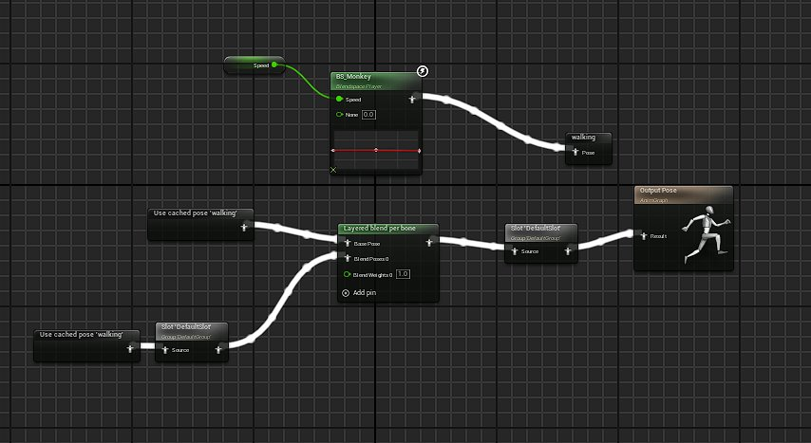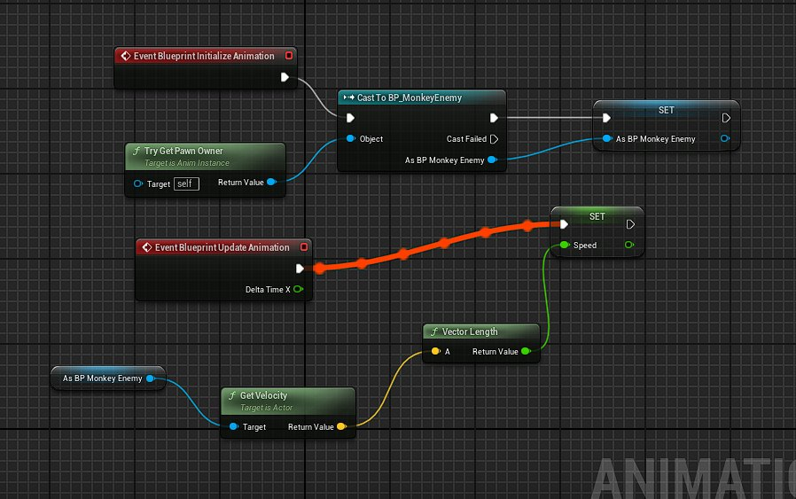

Rose turret
The turret enemy was easier to implement than the monkey enemy ended up being however came with issues of its own. Due to its stationary nature the enemy did not need a behavior tree as such and was therefore created within a single blueprint.
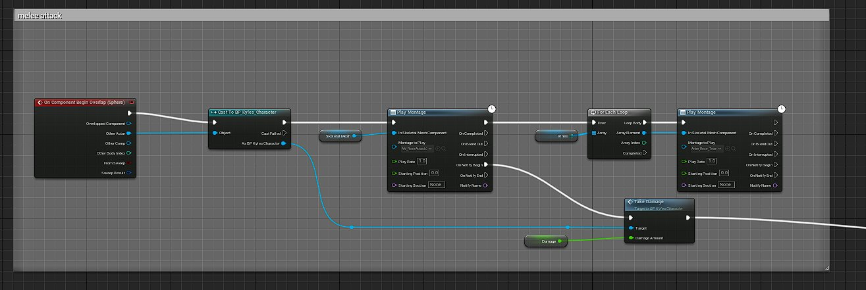As seen above the plant turret has a melee attack as the player approaches too close in order to destroy the plant it will lash out and deal damage, as well as the below seen ranged attack that activates with the pawn sensing component to constantly update the rotation of the central flower to follow the player and fire projectiles. 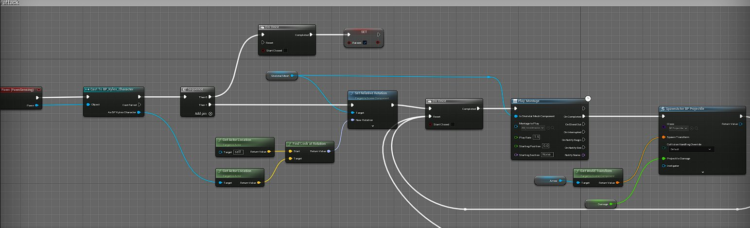

Conclusion
To conclude I feel that the journeyman module has helped me massively to improve both my technical and soft skills within a team. My scripting in previous projects has been functional however it has often been messy and hard to follow and I have now learned techniques to organize scripting and have become more conscious and aware of fellow developers who I may be working along side and how to optimize the workflow with stricter more concise code. I have also had the opportunity to work with several different disciplines within the team which has broadened my understanding of the different roles within the games industry and how they fit together to collaborate and produce a polished and cohesive piece of work.
The module has also reignited my passion for the more technical and scripting focused side of the development process and boosted the confidence I have in my abilities to complete complex programming tasks and work as a bridge between programmers and designers as my course was intended.

